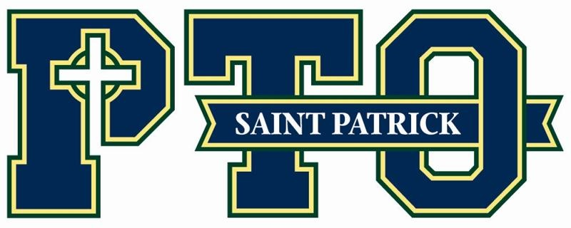
Important Dates:
Friday, November 18th and Friday December 9th-Spirit Wear Day
Wednesday, December 14th-Teacher/Staff/Parish Christmas party
Thursday, January 12th-PTO Meeting 8am
Week of January 29th-Catholic Schools Week
Saturday, March 4th-Father/Daughter Dance
Saturday, March 18th-Celtic Celidh

Date: November

President Report – Tonya Davis
- Many thanks to our PTO volunteers and their contributions to the PTO so far this school year!
  - Erin Wernert, Melissa Anderson, Lisa Bauer, Lauren Alderman, Amy Sheehan-Color Walk
  - Lauren Alderman and Susanna Means – Open House
  - Meredith Zuhars-Lost and Found
  - Amaris Lewis-Staff Birthdays
    - 22 birthdays in Aug for summer birthdays
    - 7 birthdays in September 4 birthdays in Oct
    - 7 birthdays in Nov
  - Students made cards to veterans day and the school is sending them to the KY National Guard
  - Catholic Service Appeal-We have a goal of 333 families participating. Money raised from CSA goes to faith formation, conferences, workshops, and parish resources. It also helps with youth ministries. Lots of resources are supported by this.
  - Children’s Formation is a great way to get children and families involved. Tammy Kessler does a great job with some fun activities. Next one is Dec 9th-Nativity Night

- Treasurer Report – Leigh Skorupa
- 2022-2023 - To Date:
  - Balance-$190,288
  - Expenses- $19,044
  - Income $96,060

Committee Reports:
- Fundraising purchases for school
  - Elementary Library
  - DRA Kits (K-3)
  - Bike Rack
  - Gaga Pit
  - Extending to Monday, September 12th

Principal Report – Dr. Sturtzel
- One trimester down! Report cards heading home soon
- Had 48 students participate in KYA. 3 bills from St. Patrick’s students and all 3 bills passed in the majority of house and senate. The entire group was voted the most outstanding delegation. This is the highest honor and voted on by other schools. 3 kiddos voted outstanding speakers.
- Other clubs and activities are getting back in the swing of things. Broadcast club is filming their first TV show.
- Student behavior is a work in progress. Behavior is circulium. Using poor choices as a teachable moment. What was incorrect and what could be done differently. Helping them with self regulation and regulating their bodies. Sitting still and focusing.
- Continuing with the celtic citizenship. Celebrating behavior and when they’re doing all the right things.
- 8th grade trip to Washington DC is back. 49 students are going. Raising money through individual and group fundraising.
- Save the date for December 12th. Social media presentation. There will be a day time presentation for students (one with 5th and 6th and one with 7th and 8th) and night time presentation for families. This will talk about the dangers of social media.
- Changing the second professional in service date to January 17th

Mrs. Block-
- The library is getting a face lift. New furniture and book shelves. Updating the books to current publications.
- Elementary and Middle school librarians will work together.
- Library is more than checking out and reading books. It is STEM and this space will allow the students so many opportunities.

Next Meeting scheduled for 8:00am January 12th in Schindler Hall.

